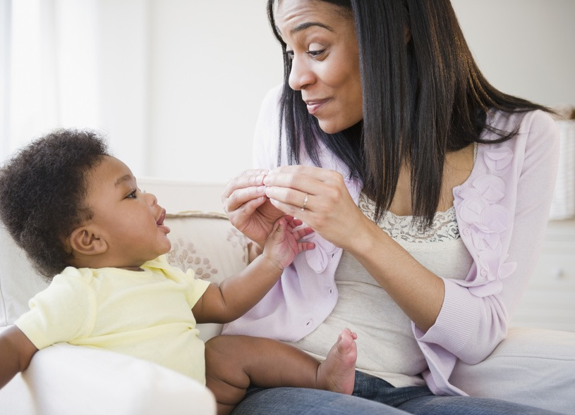
PARENTS
Is your child deaf or hard of hearing
and age 36 months or younger?

If so, you are eligible for
a FREE online class
to learn American
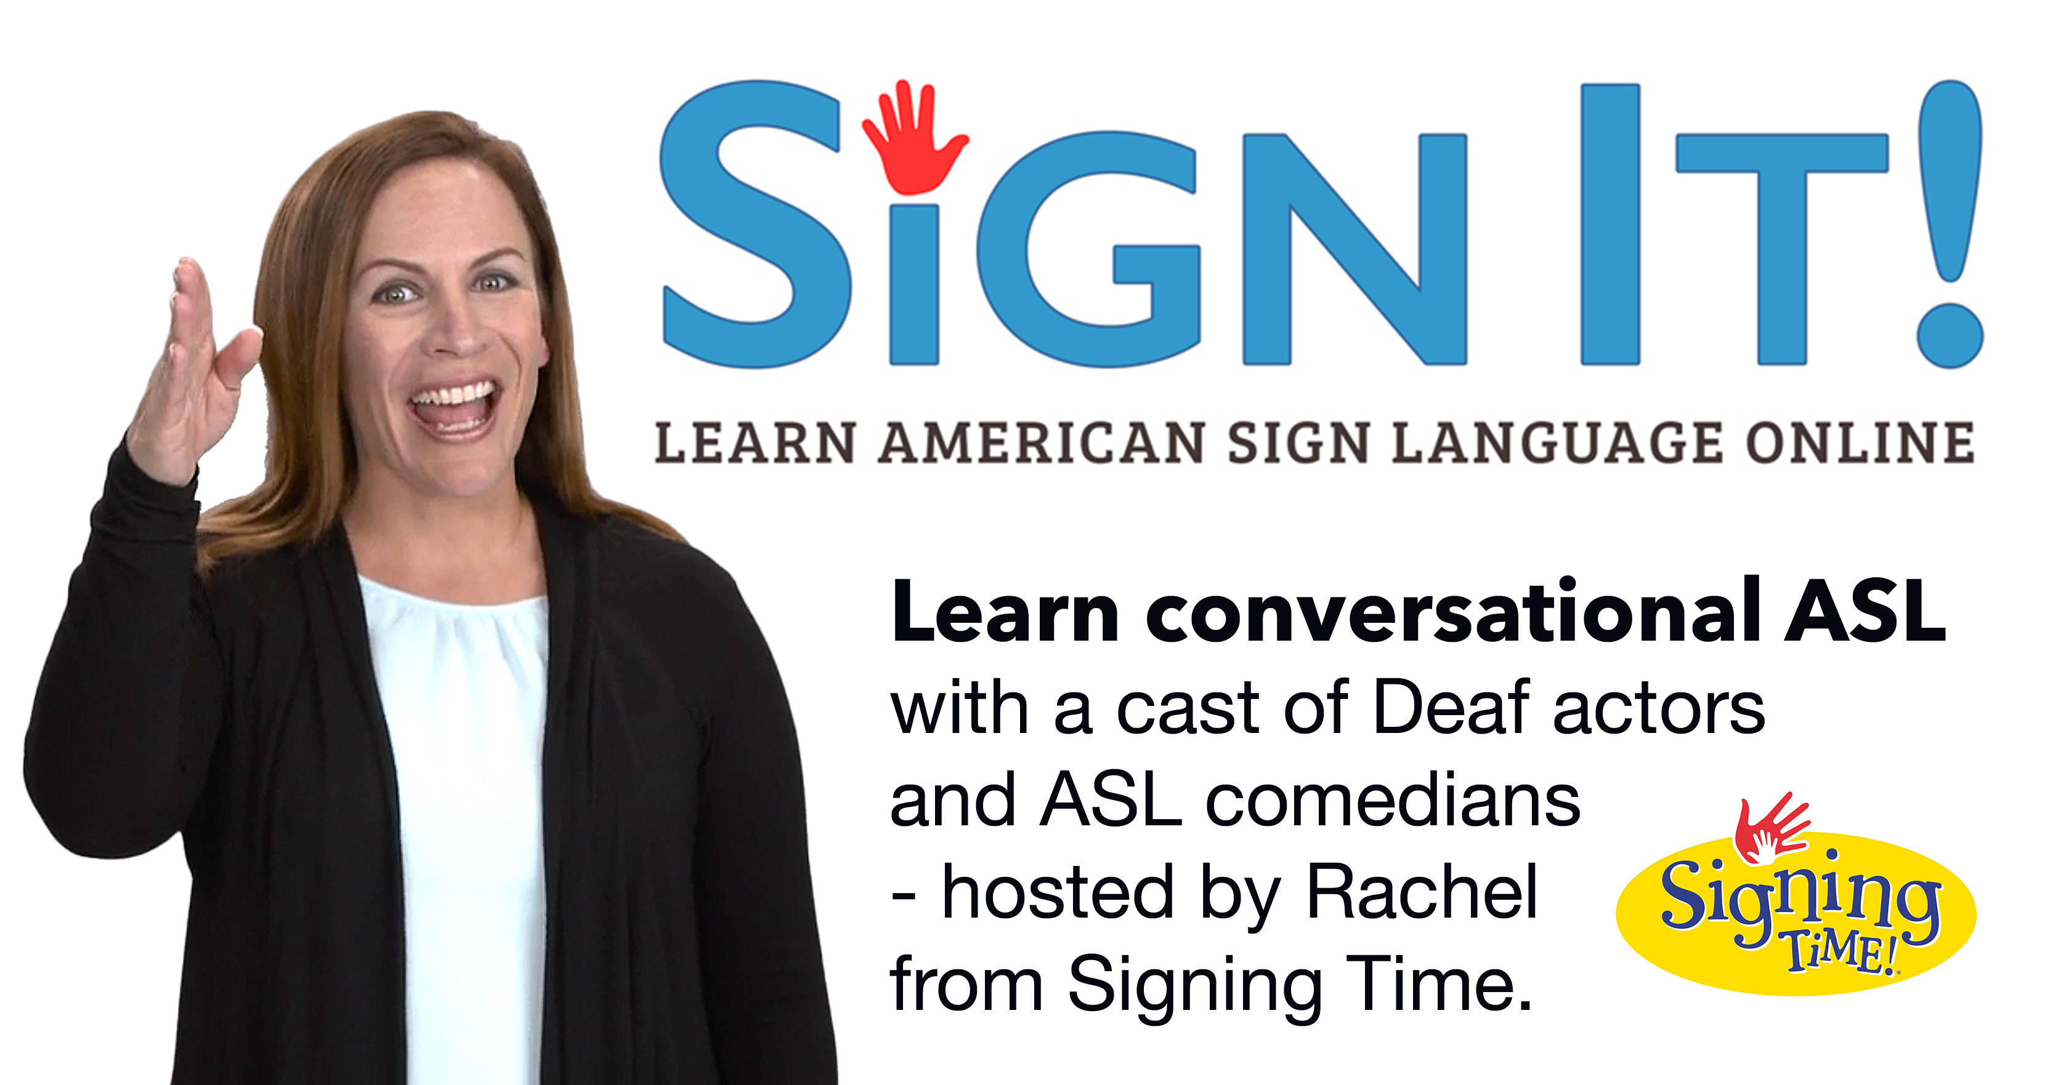
Sign Language!
Apply at MyDeafChild.org

